Job Selection Problem

AHP involves multiple pairwise comparisons, which may create some inconsistency between comparisons. Hence we need to check whether your comparison is consistent or not. This provides a step-by-step example using a simple job selection example.

Objective: To use the AHP method to help Jane select a job that is best in terms of the various job criteria.

Criterion 1: High starting Salary

Criterion 2: Quality of life in city where job is located

Criterion 3: Interest of work

Criterion 4: Nearness of job to family
Jane currently has three jobs offers: Job1, Job2, job3.
Step One: Develop Your Hierarchy
Based on the problem structure described above, we can develop the following hierarchy
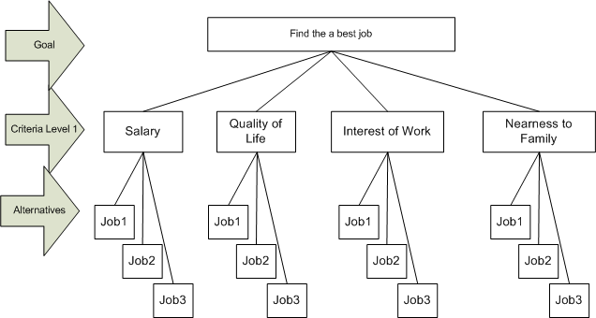
Figure 1: An Job Selection Hierarchy

Step Two: Establish Your Priorities between criteria
- Rank the importance of each criterion relative to the others, using the scale below.
Relative Importance | Value
Equal importance/quality | 1
Somewhat more important/better | 3
Definitely more important/better | 5
Much more important/better | 7
Very much more important/better | 9

Note 1:
The numbers 2, 4, 6, and 8 are half way positions between the values above.
Note 2:
The scale assumes that the ROW (first) criterion being ranked is of equal or greater importance than the COLUMN (second) criterion. If you have a pairing where the row criterion is less important than the column, use the reciprocal value (1/3, 1/5, 1/7, or 1/9).

Step Three: Conduct pairwise comparison and compute weight matrix
- Let us assume that we have obtained the following pairwise comparison matrix, A
 | Salary | Quality | Interest | Nearness
Salary | 1 | 5 | 2 | 4
Quality | 1/5 | 1 | ½ | 1/2
Interest | 1/2 | 2 | 1 | 2
Nearness | 1/4 | 2 | 1/2 | 1
- Calculate the normalized weight matrix among Criteria, A_{norm}, using the pairwise matrix A above.
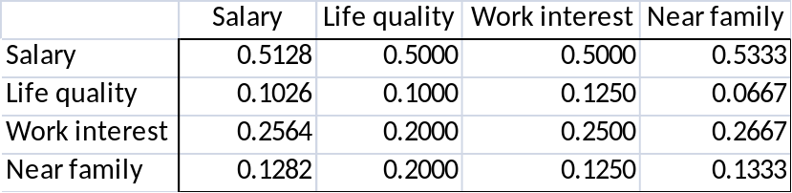

- Calculate ,w, weight for each criteria by computing the average of each row in A_{norm}
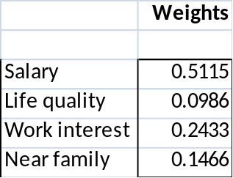

Question. Why the average of row is used to approximate the weight of each criterion (e.g. salary)?
Answer: The proportion of weight that salary is given in pairwise comparison of each criterion to salary is 0.5128, 0.5000, 0.5000, and 0.5333, respectively. Therefore, we see that each of the four numbers averaged to obtain the weight of salary represents a measure of the total weight attached to salary. Averaging these numbers should give a good estimate of the proportion of the total weight given to salary.
- Please note that that pairwise comparison matrix A may not be consistent.

For example, Jane claims that salary is definitely more important than quality of life (i.g. cell(1,2) = 5) and that salary is somewhat slightly more important than Interest of work (i.e. cell(1,3) = 2). This logically indicates that Interest of Work is more important than Quality of Life by three level of difference. However as seen in the comparison between Interest and Quality of Life, cell (3,2) = 2, the difference between Interest and Quality is 2. This indicates that some of Jane’s pairwise comparisons are slightly inconsistent.

Therefore, it is important to check the consistency of the pairwise comparison in AHP. For this follow the steps described below.
How to Check Consistency of A?
Any pairwise comparison matrix can suffer from inconsistencies. We now describe a procedure to check for inconsistencies. We illustrate this on the A matrix and its associated vector of weight, w

- Compute Aw. For example, we obtain the following product
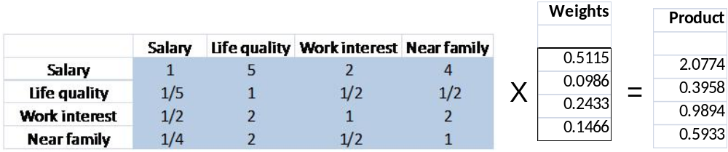

- Find the ratio of each element of Aw to the corresponding weight in w and average these ratios. For example, this averaged ratio is
$$\frac{\frac{2.0774}{0.5115}+\frac{0.3958}{0.0986}+\frac{0.9894}{0.2433}+\frac{0.5933}{0.1466}}{4}=4.0477$$
- Compute the Consistency Index (CI) as
$$CI= \frac{\left(averaged ratio above\right)- n}{n-1}$$
, where n is the number of comparisons, n=4 in this example since we have four comparisons based on four criteria.
$$CI= \frac{\left(4.0477\right)- 4}{4-1}=0.0159$$
Saaty (T.L. Saaty, The Analytic Hierarchy Process. ( New York 1980)) has shown that if the decision maker is completely consistent then,

- aij . ajk = aik (for all i,j,k),
- λ_{max} and λ_{average} = n where λ is an eigenvalue of the matrix A
- CI = 0.
If you are more interested in the theory of consistency index, refer to “CONSISTENCY IN THE ANALYTIC HIERARCHY PROCESS”, International Journal of Uncertainty, Vol. 14, No. 4 (2006) pp. 445−459
- Compute the Consistency Ration (CR) as
$$CR= \frac{CI}{RI}$$
, where RI is a random consistency index (RI) provided by Saaty as follows:
Random Consistency Index Table.
n | 2 | 3 | 4 | 5 | 6 | 7 | 8 | 9 | 10
RI | 0 | 0.58 | 0.90 | 1.12 | 1.24 | 1.32 | 1.41 | 1.45 | 1.51
(The values in the table give the average value of CI if the entries in A were chosen at random)
$$CR= \frac{CI}{RI}=\frac{0.0159}{0.90}=0.0176$$
Saaty suggested that if CR < 0.1, the degree of consistency is satisfactory. Otherwise, it is considered inconsistent, and you may revise the pairwise comparison. Since in this case, CR = 0.0176 < 0.1, the pairwise comparison is considered consistent for weight of criteria.

Now we can repeat the above procedure for the weight of alternatives on each criterion as follows:
Step Four: Conduct pairwise comparison among jobs on salary
Pairwise comparison matrix: A
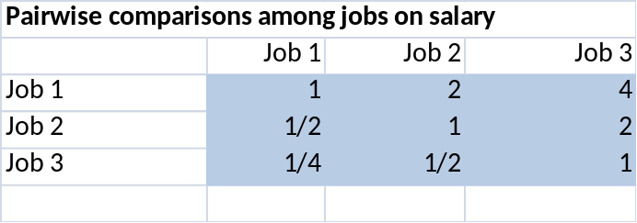
Normalized matrix A_{norm}
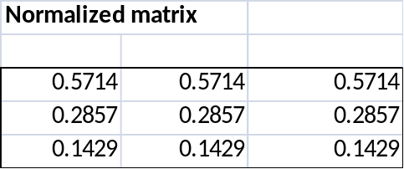
Weight (w) for jobs on salary
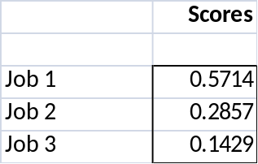
Using Aw, we obtain the following product
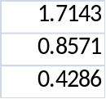
Averaged ratio based on Aw is given by
$$\frac{\frac{1.7143}{0.5714}+\frac{0.8571}{0.2857}+\frac{0.4286}{0.1429}}{3}=3$$
$$CI= \frac{\left(3\right)- 3}{3-1}=0$$
Please note that there are three alternatives (n = 3).
$$CR= \frac{CI}{RI}=0$$
Exercise:
Complete weight and consistent ratio calculation procedure for remaining part of the problem when the following information is given:

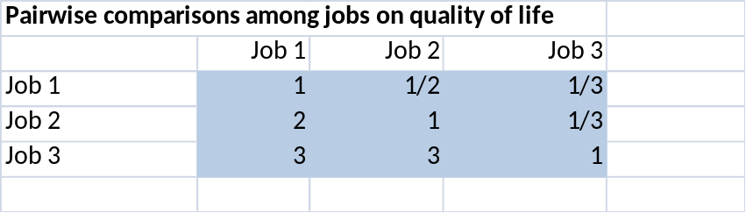

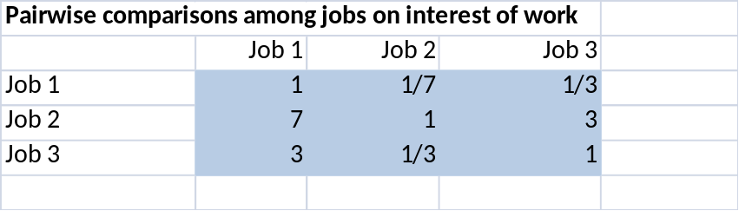

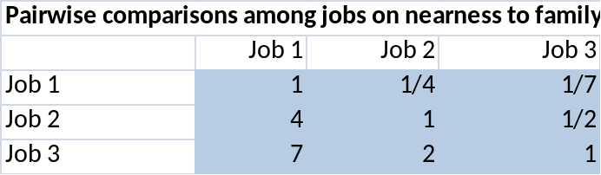

Conclusion:
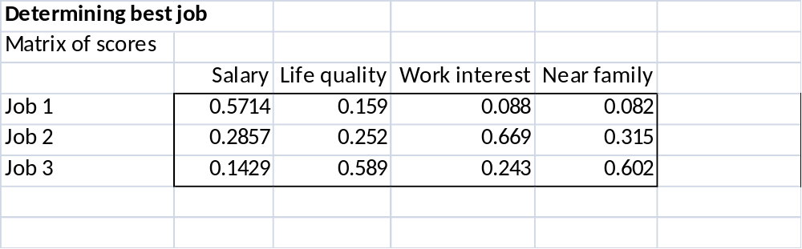
Job 2 has the highest ratio!!
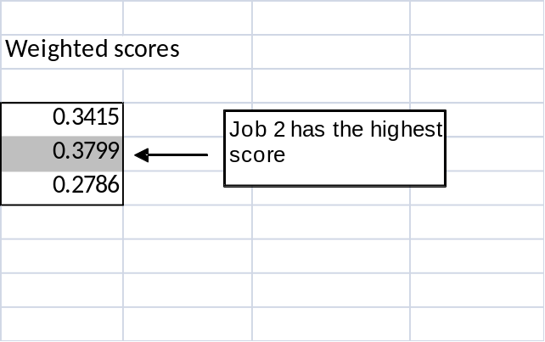
All procedures and solutions are explained in the following Excel document

Question: We have discussed the way to calculate the consistency at each step. Now we can check the overall consistency of hierarchy by summing for all levels, with weighted consistency index (CI) in the nominator and weighted random consistency index (RI) in the denominator. Overall consistency of the hierarchy in our example above is given by
$$\overline{CR}=\frac{\sum_{i}{w_{i}{CI}_{i}}}{\sum_{i}{w_{i}{RI}_{i}}}$$
$$=\frac{\left(1\right)\left(0.0159\right)+\left(0.5115\right)\left(0\right)+\left(0.0986\right)\left(0.0270\right)+\left(0.2433\right)\left(0.0035\right)+\left(0.1466\right)\left(0.0010\right)}{\left(1\right)\left(0.90\right)+\left(0.5115\right)\left(0.58\right)+\left(0.0986\right)\left(0.58\right)+\left(0.2433\right)\left(0.58\right)+\left(0.1466\right)\left(0.58\right)}$$
= 1.32%

How to manage 2x2?
According to Random Consistency Index Table, RI = 0 for n = 2.
n | 2 | 3 | 4 | 5 | 6 | 7 | 8 | 9 | 10
RI | 0 | 0.58 | 0.90 | 1.12 | 1.24 | 1.32 | 1.41 | 1.45 | 1.51
Then what is CI for n = 2?
By definition CI for n = 2 always since there is only one pairwise comparison. For example, consider the following example.
 | 1 | 3
 | 1/3 | 1
sum | 1.333333 | 4

 |  |  | PV
normalized | 0.75 | 0.75 | 0.75
 | 0.25 | 0.25 | 0.25
Aw = $\left(\begin{matrix}1 & 3 \\ 1/3 & 1\end{matrix}\right)\left(\begin{matrix}0.75 \\ 0.25\end{matrix}\right)=(\begin{matrix}1.5 \\ 0.5\end{matrix})$
To calculate CI, we need the averaged ratio based on Aw, given by
$$\frac{\frac{1.5}{0.75}+\frac{0.5}{0.25}}{2}=2$$
$$CI= \frac{\left(2\right)- 2}{2-1}=0$$
Recall $$\overline{CR}=\frac{\sum_{i}{w_{i}{CI}_{i}}}{\sum_{i}{w_{i}{RI}_{i}}}$$
If 2x2 is use in evaluating $\overline{CR}$, then its numerator and denominator both become zero!

